
CWPA
Planning & Architecture
Unit 10 North Street Business Park,
Seatown West,
Swords, Co. Dublin, K67C992
Phone: 01-6856616
email: hq@cwpa.ie
web: www.cwpa.ie

Fingal County Council
Planning Department
County Hall
Main Street
Swords
County Dublin
K67 X8Y2

August 23rd , 2023
Subject: Stage 2 LRD Meeting Request with Fingal County Council
Development: 120 no. bed Large Scale Residential Development (LRD)
Subject Site: Grange Road, Baldoyle, Dublin 13
Stage 1 S. 247 Reg. Ref: LRD0019/S1

Dear Sir/ Madam,
CWPA Planning and Architecture, Unit 10, North Street Business Park, Townparks, Seatown West, Swords, Co. Dublin, K67 C992, wish to request this Stage 2 LRD Meeting request on behalf of Rondesere Ltd in accordance with Section 32 (B) of the Planning and Development (Amendment) (Large-scale Residential Development) Act 2021. The proposed development consists of 120 no. apartments on lands located to at Grange Road, Baldoyle, Dublin 13.
2 no. hard copies and 1 no. digital copy of the following drawings and documents are enclosed with this submission.
CWPA Planning & Architecture | - Completed LRD Meeting Request Application Form.  - Cover Letter.  - Planning Report and Statement of Consistency.  - Full suite of architectural drawings an Issue Sheet attached to drawing pack.  - Design Report.
Waterman Moylan Consulting Engineers | - Full suite of engineering drawings and reports.
RMDA Landscape Architects | - Full suite of landscape drawings and associated Landscape Rationale Report.
Digital Dimensions | - Daylight and Sunlight Assessment in accordance with the Building Research Establishment (BRE) BR209:2022 “Site Layout Planning for Daylight and Sunlight” (Third Edition).  - Photomontage Booklet.
We trust that all relevant documentation has been enclosed, however, please do not hesitate to contact us on any issue arising.
Yours Sincerely,
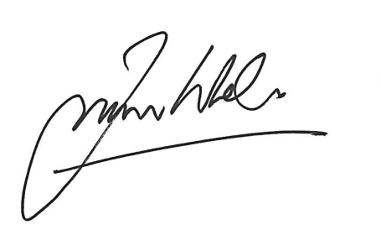

_________________________
Francis Whelan MRIAI
Managing Director (Architecture)



